TYPE THE TITLE OF YOUR PAPER HERE, PLEASE USE ITALIC FOR SPECIES NAME
First Author*¹, Second Author² and Third Author³
¹author’s institution and address
²author’s institution and address
³author’s institution and address
*Corresponding author: author e-mail
Received: ; Accepted: (to be filled by editor)
ABSTRACT
Except for short communications, articles should be accompanied by an abstract. The abstract consists of no more than 250 words in one paragraph which should clearly state the essence of the paper, with no references cited.
Key words: word 1, word 2, word 3, word 4, word 5

INTRODUCTION
The introduction must briefly justify the research and give the objectives. References related to the justification of the research should be cited in the introduction but extensive and elaborate discussion of relevant literature should be addressed in the Discussion section. References are to be cited in the text by the author’s surname and year of publication. When citing multiple sources, place them in chronological order, e.g. (MacKinnon & Phillips, 1993; LaSalle & Schauff, 1994). For two authors, both names should be cited: e.g. (LaSalle & Schauff, 1994). For three authors or more, only the surname of first author is given followed by et al., e.g. (Eaton et al., 2016).
MATERIALS AND METHODS
Provide a clear explanation of materials and methods used in the research. The place of specimen depository must be mentioned here.
RESULTS
The results can be presented in the form of tables and figures when appropriate. The text should explain and elaborate the data presented. Captions of tables, figures, and plates should be inserted where you want them to be inserted. All line drawings, photographs and other figures may be submitted in JPEG format and the image size should be at least 1024 by 768 pixels.

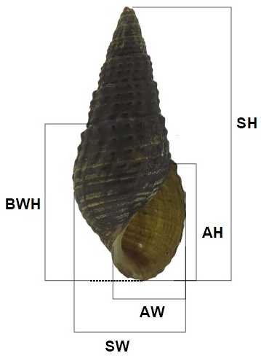
Figure 1. Parameters used to measure the shell dimensions (SH: shell height, SW: shell width, BWH: body whorls height, AH: aperture height and AW: aperture width).
Table 1. Sample of L. hasseltii and outgroup species used for mtDNA analysis in this study together with the information on voucher, collection locality and GenBank accession numbers.
Samples | Species | Voucher | Locality | Gene Bank
1 | L. chapaense | KUHE 19122 | Thailand, Doi Intanon, Ban Khun Klang | AB530444, AB646428
2 | L. smithi | KUHE 19834 | Thailand, Mae Hong Son, Phasua WF | AB530434
3 | L. nigrops | ZRC L SG002 | Singapore, Seletar | AB719239
DISCUSSION
The discussion should interpret the results clearly and concisely, and should discuss the findings in relation with previous publications.
ACKNOWLEDGMENTS
Acknowledgements of grants, assistance and other matters can be written here in one paragraph.
REFERENCES
Eaton, J.A., van Balen, B., Brickle, N.W. & Rheindt, F.E. 2016. Birds of the Indonesian Archipelago: Greater Sundas and Wallacea. 1st ed. Barcelona: Lynx Edicions.
LaSalle, J. & Schauff, M.E. 1994. Systematics of the tribe Euderomphalini (Hymenoptera: Eulophidae): parasitoids of whiteflies (Homoptera: Aleyrodidae). Systematic Entomology 19: 235-258.
MacKinnon, J. & Phillips, K. 1993. Field Guide to the Birds of Borneo, Sumatra, Java and Bali. Oxford Unversity Press, Oxford, 491 pp.

